**GANPAT UNIVERSITY**

**U.V.PATEL COLLEGE OF ENGINEERING & TECHNOLOGY**

**Department of Computer Science and Engineering**

**B.Tech 1ST Semester   Subject –**

**First Name: MALAV SHASTRI      Enrollment Number: -------                   Stream :BDA**

**ASSIGNMENT – ESFP 1                                                                                 Date:27/08/2014**

**1) 1. Write a program to print ASCII values of all backslash characters and white space on screen** ***in following format :***

**The ASCII value of ‘\t’ is : 9**

***Ans)***

#include<stdio.h>

#include<conio.h>

void main()

{

char a;

clrscr();

a='\a';

printf("\nthe ascii value of'\\a' is:%d",a); //to print ascii value of \a.

a='\b';

printf("\nthe ascii value of '\\b' is:%d",a); //to print ascii value of \b

a='\f';

printf("\nthe ascii value of '\\f' is:%d",a); //to print ascii value of \f

a='\n';

printf("\nthe ascii value of '\\n' is:%d",a); //to print ascii value of \n

a='\r';

printf("\nthe ascii value of '\\r' is:%d",a); //to print ascii value of \r

a='\t';

printf("\nthe ascii value of '\\t' is:%d",a); //to print ascii value of \t

a='\v';

printf("\nthe ascii value of '\\v' is:%d",a); //to print ascii value of \v

a='\?';

printf("\nthe ascii value of '\\?' is:%d",a); //to print ascii value of \?

a='\\';

printf("\nthe ascii value of '\\\' is:%d",a); //to print ascii value of \\

getch();

}

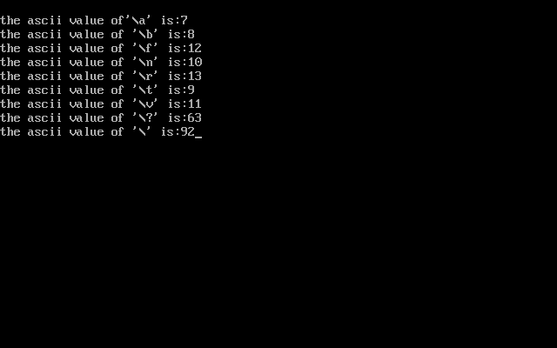

***2)  Explain different data types available in C***.

|  |
| --- |
| The variety of data types available allows the programmer to select the type appropriate to the needs of the application.  Here we are taking about primary data types. Besides primary data type there are more 2 kind of data types like User define data types, derived data types.  All C complilers have five fundamental data types 1)integer 2)character 3)float 4)double 5)void. There are also some extended data types like long integer, long double etc.  ***1)Integer Types:***  Integers are whole number The size of an integer that can be stored depends upon computer. Generally integers have two kind of word length *16bits *32bits.If we are using 16 bits its value is limited to the range -32768 to +32767. As well as 32 bits word length can store a wide range .  ***2)Float & Double:***  Generally floats number is for decimals. But for more accuracy we can use double. A double data types number uses 64 bits giving a precision of 14 digits. For more accuracy we can use long double.\  ***3)Void data types:***  The void types has no values. This is usually used to specify the type of function. The type of a function is said to be void when it does not return any value to the calling function.  ***4)Character data types:***  A single character can be defined as a character type data. Characters are usually stored in 8 bits of internal storage. Unsigned characters have value between 0 to 255 and signed have values between -128 to 127. |
| ***3). Explain about C Tokens in brief.***  ***Ans):***  In a c program the smallest individual units are known as C tokens. |
| ***4)*** ***Explain about backslash characters in C.***  ***Ans):***  There are some backslash characters that are used in output functions. Backslash characters gives some effect in program like tab, new line etc. The list of some backslash characters :   | **Escape sequence** |  |  | **Character represented** | | --- | --- | --- | --- | | \a |  |  | Alarm (Beep, Bell) | | \b |  |  | Backspace | | \f |  |  | Formfeed | | \n |  |  | Newline (Line Feed); see notes below | | \r |  |  | Carriage Return | | \t |  |  | Horizontal Tab | | \v |  |  | Vertical Tab | | \\ |  |  | Backslash | | \' |  |  | Single quotation mark | | \" |  |  | Double quotation mark | | \? |  |  | Question mark | |

Ans)